 | CS2304 SYSTEM SOFTWARE
 | QUESTION BANK | - UNIT-I
.

1) What is system software?

System software consists of variety of programs that supports the operations of a computer. This makes it possible for the user to focus on an application or other problem to be solved ,without needing to know the details of how the machine works internally.

Examples of system software are text-editors,compilers,loaders or linkers,debuggers,assemblers,and operating systems.

- How system software is different from Software?

The most important characteristic in which most system software differ from application software is machine dependency.

An application program is primarily concerned with the solution to some problem,using computer as a tool. The focus is on the application,not on the application system.

System programs, on the other hand,are intended to support the operation and use of the computer itself,rather than any particular application. They are usually related to the architecture of the machine on which they are to run.

3) Explain the machine dependency of system software with examples?

An assembler is a system software. It translates mnemonic instructions into machine code; the instruction formats,addressing modes ,etc,are of direct concern in assembler design. Similarly, compilers must generate machine language code,taking into account such hardware characteristics as the number and the types of registers and machine instructions available Operating systems are directly concerned with the management of nearly all of the resources of a computer system.
- Example:

- When you took the first programming course

  - Text editor - create and modify the program
  - Compiler- translate programs into machine language
  - Loader or linker - load machine language program into memory
- and prepared for execution

  - Debugger - help detect errors in the program
- When you wrote programs in assembler language

  - Assembler - translate assembly program into machine language

  - Macro processor - translate macros instructions into its definition
- When you control all of these processes

  - By interacting with the OS

- What are the important machine structures used in the design of system software?

➢ Memory structure ➢ Registers
➢ Data formats
➢ Instruction formats ➢ Addressing modes ➢ Instruction set

- What is SIC machine?

SIC refers to Simplified Instruction Computer which is a hypothetical computer that has been designed to include the hardware features most often found on real machines,while avoiding unusual and irrelevant complexities. This allows to clearly separate the central concepts of a system software from the implementation details associated with a particular machine.
- Explain SIC Machine architecture. SIC Machine Architecture
➢ Memory
o 215 bytes in the computer memory o 3 consecutive bytes form a word o 8-bit bytes

➢ Registers

Mnemonic | Number | Special use
A | 0 | Accumulator; used for arithmetic operations
X | 1 | Index register; used for addressing
L | 2 | Linkage register; JSUB
PC | 8 | Program counter
SW | 9 | Status word, including CC
- Data Formats

- Integers are stored as 24-bit binary numbers; 2’s complement representation is used for negative values
  - No floating-point hardware
- Instruction Formats

 |  | opcode (8) |  | x |  | address (15)
➢ Addressing Modes
 | Mode |  | Indication |  |  | Target address calculation
 | Direct |  | x=0 |  |  | TA=address
 | Indexed |  | x=1 |  |  | TA=address+(X)
➢ Instruction Set
- integer arithmetic operations: ADD, SUB, MUL, DIV, etc.
  - All arithmetic operations involve register A and a word in memory, with the result

being left in the register
- comparison: COMP

  - COMP compares the value in register A with a word in memory, this instruction sets a condition code CC to indicate the result
  - conditional jump instructions: JLT, JEQ, JGT
    - these instructions test the setting of CC and jump accordingly

  - subroutine linkage: JSUB, RSUB
    - JSUB jumps to the subroutine, placing the return address in register L

    - RSUB returns by jumping to the address contained in register L

- Input and Output

  - Input and output are performed by transferring 1 byte at a time to or from the rightmost 8 bits of register A
- The Test Device (TD) instruction tests whether the addressed device is ready to send or receive a byte of data

  - Read Data (RD) o Write Data (WD)

- What are the contents of status word register?
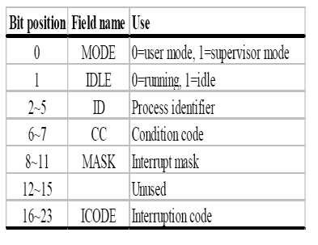

8)Explain SIC/XE architecture SIC/XE Machine Architecture

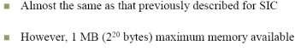
➢ Memory

  - More Registers
Mnemonic | Number | Special use
B | 3 | Base register; used for addressing
S | 4 | General working register
T | 5 | General working register
F | 6 | Floating-point acumulator (48bits)
➢ Data Formats
  - Floating-point data type: frac*2(exp-1024)
    - frac: 0~1

    - exp: 0~2047

- Instruction Formats

Format 1

op(8)

Format 2

op(8) | r1(4) | r2(4)

Format 3 |  |  |  |  |  | e=0
op(6) | n | I | x | b | p | e |  | disp(12)


Format 4 |  |  |  |  |  | e=1
op(6) | n | I | x | b | p | e |  | address (20)

- Instruction Set
- new registers: LDB, STB, etc.

  - floating-point arithmetic: ADDF, SUBF, MULF, DIVF o register move: RMO

o register-register arithmetic: ADDR, SUBR, MULR, DIVR
o supervisor call: SVC
    - generates an interrupt for OS

- Input/Output
SIO, TIO, HIO: start, test, halt the operation of I/O device

- Explain SIC/XE Instruction formats.
➢ Instruction Formats
• Larger memory means an address cannot fit into a 15-bit field
➢ Extend addressing capacity

• Use some form of relative addressing -> instruction
➢ format 3

• Extend the address field to 20 bits -> instruction format 4
➢ Additional instructions do not reference memory

• Instruction format 1 & 2

- Explain SIC/XE addressing modes.

- How to compute TA? Addressing modes:

 | Mode | Indication |  | Target address calculation | operand
 | Base relative | b=1, p=0 |  | TA=(B)+disp (0<=disp<=4095) | (TA)
 | PC-relative | b=0, p=1 |  | TA=(PC)+disp (-2048<=disp<=2047) | (TA)
 | Direct | b=0, p=0 |  | TA=disp (format 3) or address (format 4) | (TA)
 | Indexed | x=1 |  | TA=TA+(X) | (TA)
 | ➢ How the target address |  |  | is used?

Mode | Indication | operand value
immediate addressing | i=1, n=0 | TA
indirect addressing | i=0, n=1 | ((TA))
simple addressing | i=0, n=0 | SIC instruction (all end with 00)
 | i=1, n=1 | SIC/XE instruction

- Addressing modes

  - Base relative (n=1, i=1, b=1, p=0)

  - Program-counter relative (n=1, i=1, b=0, p=1)
  - Direct (n=1, i=1, b=0, p=0)

  - Immediate (n=0, i=1, x=0)

  - Indirect (n=1, i=0, x=0)

  - Indexing (both n & i = 0 or 1, x=1)

  - Extended (e=1 for format 4, e=0 for format 3)

- What is direct addressing?
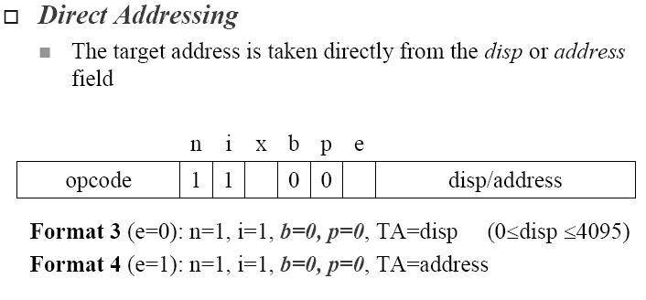

15) What is indexed addressing?
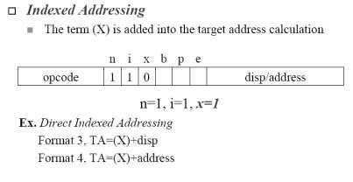

- What is immediate addressing?

- What is indirect addressing?
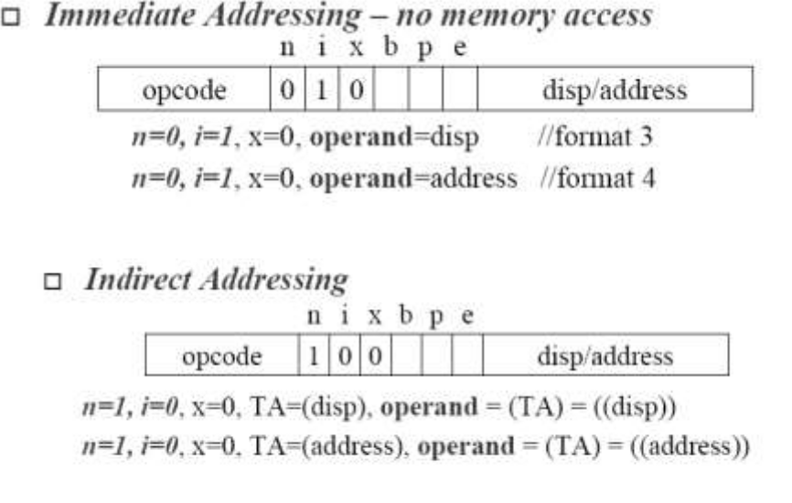

18) What is simple addressing mode?

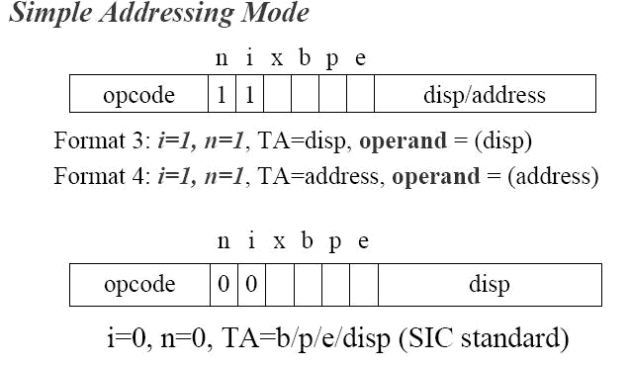

- What are the instruction set for SIC/XE? Instruction Set

  - new registers: LDB, STB, etc.
  - floating-point arithmetic: ADDF, SUBF, MULF, DIVF
  - register move: RMO

  - register-register arithmetic: ADDR, SUBR, MULR, DIVR
  - supervisor call: SVC
    - generates an interrupt for OS (Chap 6)

Input/Output
  - SIO, TIO, HIO: start, test, halt the operation of I/O device

- Give programming examples of SIC.
SIC Programming Examples

-- Data movement

ALPHA | RESW | 1
FIVE | WORD | 5
CHARZ | BYTE C’Z’
C1 | RESB 1
 | .
 | .
 | LDA | FIVE
 | STA | ALPHA
 | LDCH | CHARZ
 | STCH | C1

(a)

- No memory-memory move instruction

- 3-byte word:
  - LDA, STA, LDL, STL, LDX, STX
- 1-byte:

  - LDCH, STCH
- Storage definition

  - WORD, RESW
  - BYTE, RESB
- All arithmetic operations are performed using register A, with the result being left in register A.

Arithmetic operation
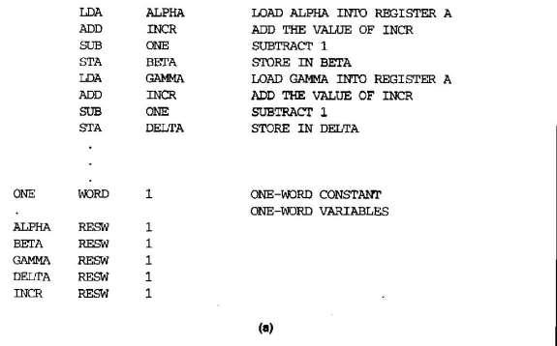

Looping and indexing
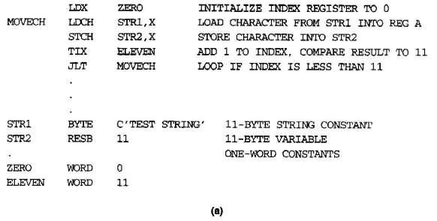

21) Give an example for SIC IO programming.

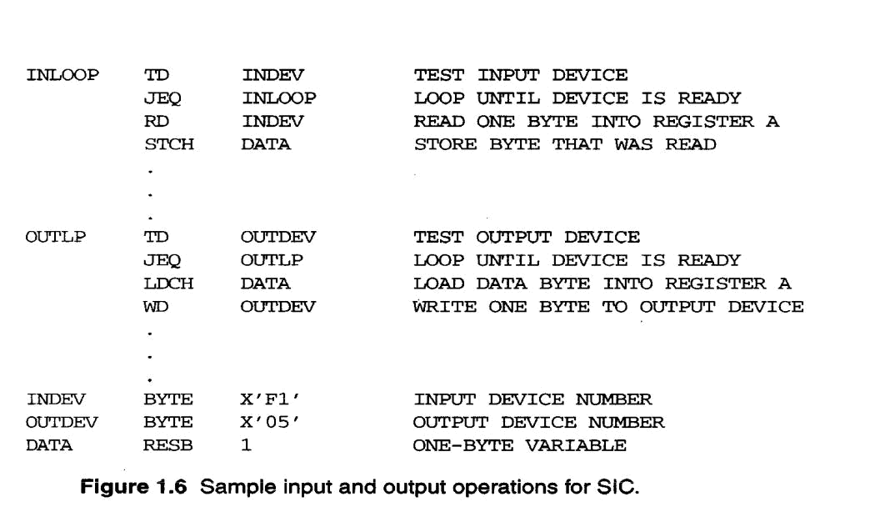

22) Explain Pentium Pro Architecture.

Pentium Pro Architecture
- Memory

- physical level: address are byte addresses

  - word (2 bytes), doubleword (or dword) (4 bytes)
  - Some operations are more efficient when operands are aligned
- logical level: programmers usually view the x86 memory

as a collection of segments.

- An address consists of segments and offsets
- In some cases, a segment can also be divided into pages

- The segment/offset address specified by the programmer is translated into a physical address by the x86 MMU (Memory

- Registers

- Eight 32-bit general-purpose registers:

  - EAX, EBX, ECX, EDX: data manipulation
  - ESI, EDI, EBP, ESP: address
- Special-purpose registers:

  - Two 32-bit registers:
- EIP: pointer to the next instruction

- FLAGS: status word

  - Six 16-bit segment registers:
- CS: code segment register

- SS: stack segment register

- DS, ES, FS, and GS: data segments

- Floating-point unit (FPU)

- All above registers are available to application programmers

  - Other registers used only by system programs such as OS.

