SYSTEM SOFTWARE
QUESTION BANK- | ASSEMBLERS
1) Why an Assembly Language is needed?

Programming in machine code, by supplying the computer with the numbers of the operations it must perform, can be quite a burden, because for every operation the corresponding number must be looked up or remembered. Looking up all numbers takes a lot of time, and mis-remembering a number may introduce computer bugs.
So Assembly Languages are evolved which contains mnemonic instructions corresponding to the Machine codes using which the program can be written easily.
Therefore a set of mnemonics was devised. Each number was represented by an alphabetic code. So instead of entering the number corresponding to addition to add two numbers one can enter "add".
Although mnemonics differ between different CPU designs some are common, for instance: "sub" (subtract), "div" (divide), "add" (add) and "mul" (multiply).

2) What is an Assembler?

An assembler is a program that accepts an assembly language program as input and produces its machine language equivalent along with information for the loader (An Assembler translates a program written in an assembly language to it machine language equivalent)

3) Explain the terms a)Label,b)Opcode,c)Operand,and d)Comment
(What is the format in which the assembly language program is written?).
Label field.

  - The label is a symbolic name that represents the memory address of an executable statement or a variable.
Opcode/directive fields.

The opcode (e.g. operation code) specifies the symbolic name for a machine instruction.

  - The directive specifies commands to the assembler about the way to assemble the program.

Operand field.

The operand specifies the data that is needed by a statement.
Comment field.

The comment provides clear explanation for a statement.
4) What are the basic functions of an assembler?
Functions of a Basic Assembler

Convert mnemonic operation codes to their machine language equivalents
E.g. STL -> 14 (line 10)

Convert symbolic operands to their equivalent machine addresses
E.g. RETADR -> 1033 (line 10)
Build the machine instructions in the proper format
Convert the data constants to internal machine representations

E.g. EOF -> 454F46 (line 80)
Write the object program and the assembly listing
5) What are assembler Directives?

Assembler directives are Pseudo-instructions that are not translated into machine instructions and they provide instructions to the assembler itself.

- The SIC assembler directives.
o START

Specification of the name and start address of the program.

o END

Indication of the end of the program and optionally the address of the first executable instruction.
- BYTE

Declaration of character or string constants.
o WORD
Declaration of integer constants.
  - RESB
Declaration of character variables or arrays.

o RESW
Declaration of integer variables or arrays.

- What are the functions of two pass assembler?

Functions of Two Pass Assembler
Pass 1 - define symbols (assign addresses)

o Assign addresses to all statements in the program

o Save the values assigned to all labels for use in Pass 2 o Process some assembler directives

Pass 2 - assemble instructions and generate object program Assemble instructions

- Generate data values defined by BYTE, WORD, etc. o Process the assembler directives not done in Pass 1
o Write the object program and the assembly listing

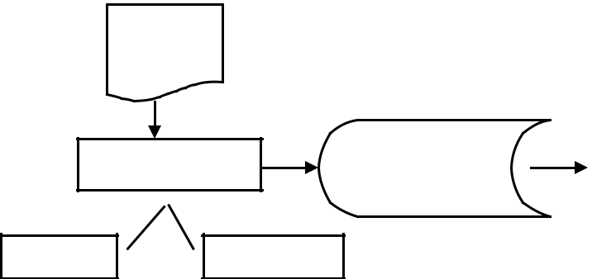
- What is the format of the Object Program generated by the Assembler? Contains 3 types of records:

Header record: Col. 1 H

Col. 2-7 Program name
Col. 8-13 Starting address (hex)
Col. 14-19 Length of object program in bytes (hex)

Text record Col.1 T
Col.2-7 Starting address in this record (hex)

Col. 8-9 Length of object code in this record in bytes (hex) Col. 10-69 Object code (hex) (2 columns per byte)

End record Col.1 E

Col.2~7 Address of first executable instruction (hex) (END program_name)

- Give an example of object program generated by an Assembler.
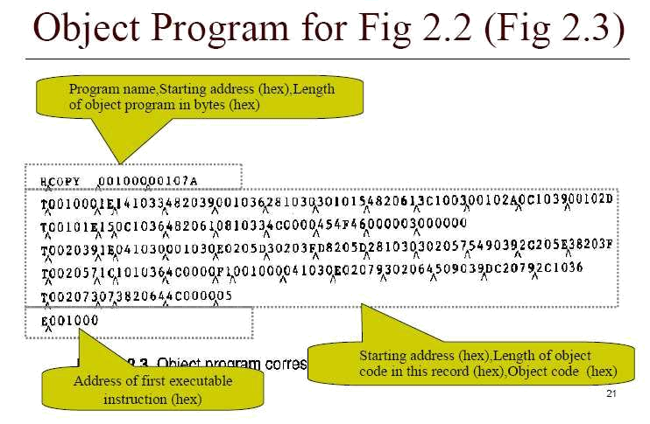

9) What is forward reference?
Forward reference is a reference to a label that is defined later in the program.

Example
10 STL RETADR

o RETADR is not yet defined when we encounter STL instruction o So it is called forward reference

10) Give an example of Assembly language along with the objectcode generated.

Line | Loc | Source statement |  |  | Object code
5 | 1000 | COPY | START | 1000
10 | 1000 | FIRST | STL | RETADR | 141033
15 | 1003 | CLOOP | JSUB | RDREC | 482039
20 | 1006 |  | LDA | LENGTH | 001036
25 | 1009 |  | COMP | ZERO | 281030
30 | 100C |  | JEQ | ENDFIL | 301015
35 | 100F |  | JSUB | WRREC | 482061
40 | 1012 |  | J | CLOOP | 3C1003
45 | 1015 | ENDFIL | LDA | EOF | 00102A
50 | 1018 |  | STA | BUFFER | 0C1039
55 | 101B |  | LDA | THREE | 00102D
60 | 101E |  | STA | LENGTH | 0C1036
65 | 1021 |  | JSUB | WRREC | 482061
70 | 1024 |  | LDL | RETADR | 081033

75 | 1027 |  |  | RSUB |  |  |  | 4C0000
80 | 102A | EOF |  | BYTE |  | C’EOF’ |  | 454F46
85 | 102D | THREE |  | WORD |  | 3 |  | 000003
90 | 1030 | ZERO |  | WORD |  | 0 |  | 000000
95 | 1033 | RETADR |  | RESW |  | 1
100 | 1036 | LENGTH |  | RESW |  | 1
105 | 1039 | BUFFER |  | RESB |  | 4096
110 |  | .
115 |  | . | SUBROUTINE TO READ RECORD INTO BUFFER
120 |  | .
125 | 2039 | RDREC |  | LDX |  | ZERO |  | 041030
130 | 203C |  |  | LDA |  | ZERO |  | 001030
135 | 203F | RLOOP |  | TD |  | INPUT |  | E0205D
140 | 2042 |  |  | JEQ |  | RLOOP |  | 30203D
145 | 2045 |  |  | RD |  | INPUT |  | D8205D
150 | 2048 |  |  | COMP |  | ZERO |  | 281030
155 | 204B |  |  | JEQ |  | EXIT |  | 302057
160 | 204E |  |  | STCH |  | BUFFER,X |  | 549039
165 | 2051 |  |  | TIX |  | MAXLEN |  | 2C205E
170 | 2054 |  |  | JLT |  | RLOOP |  | 38203F
175 | 2057 | EXIT |  | STX |  | LENGTH |  | 101036
180 | 205A |  |  | RSUB |  |  |  | 4C0000
185 | 205D | INPUT |  | BYTE X’F1’ |  | F1
190 | 205E | MAXLEN |  | WORD |  | 4096 | 001000
195 |  | .
200 |  | . | SUBROUTINE TO WRITE RECORD FROM BUFFER
205 |  | .
210 | 2061 | WRREC |  | LDX | ZERO 041030
215 | 2064 | WLOOP |  | TD | OUTPUT |  | E02079
220 | 2067 |  |  | JEQ | WLOOP |  | 302064
225 | 206A |  |  | LDCH BUFFER,X |  |  | 509039
230 | 206D |  |  | WD | OUTPUT |  | DC2079
235 | 2070 |  |  | TIX | LENGTH |  | 2C1036
240 | 2073 |  |  | JLT | WLOOP |  | 382064
245 | 2076 |  |  | RSUB |  |  | 4C0000
250 | 2079 | OUTPUT |  | BYTE X’05’ |  | 05
255 |  |  |  | END FIRST

10) Write an Algorithm for pass 1 of SIC Assembler.
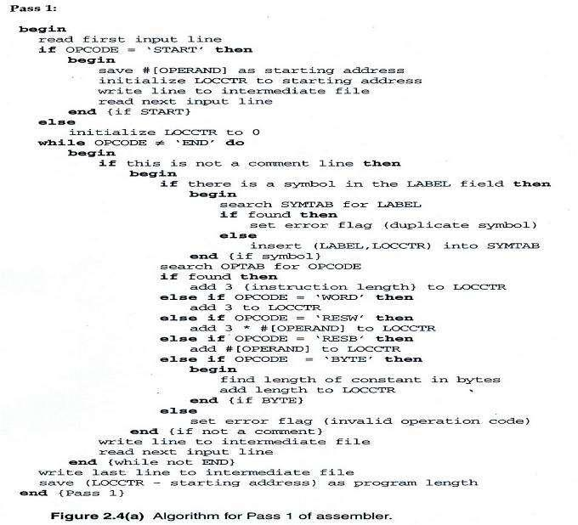
11) Write an algorithm for pass 2 of SIC assembler.
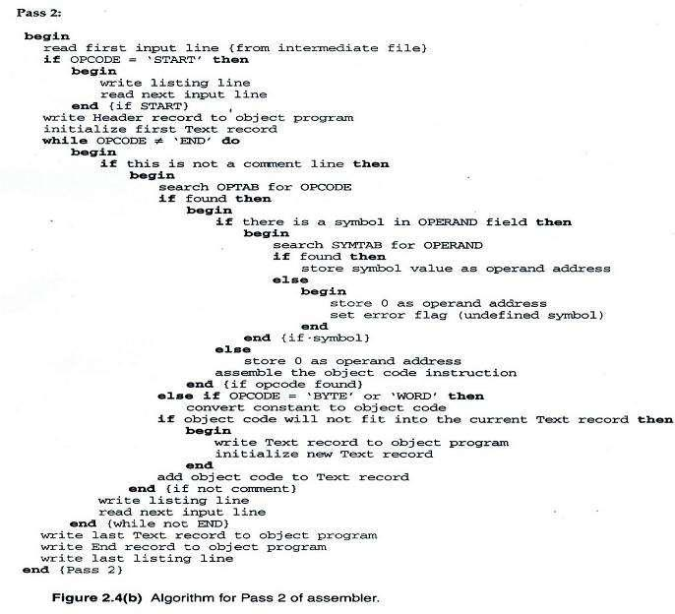

- What are the Data Structures used in an Assembler? Data Structures:

Operation Code Table (OPTAB) Symbol Table (SYMTAB) Location Counter(LOCCTR)
- Explain the features of a Symbol Table. ➢ SYMTAB (symbol table)

Content
Label name and its value (address) May also include flag (type, length) etc.
Usage
Pass 1: labels are entered into SYMTAB with their address (from LOCCTR) as they are encountered in the source program

Pass 2: symbols used as operands are looked up in SYMTAB to obtain the address to be inserted in the assembled instruction

Characteristic
Dynamic table (insert, delete, search)
Implementation
Hash table for efficiency of insertion and retrieval

COPY 1000

FIRST 1000

CLOOP 1003

ENDFIL 1015

EOF 1024

THREE 102D

ZERO 1030

RETADR 1033

LENGTH 1036

BUFFER 1039

RDREC 2039

SYMBOL TABLE(SYMTAB)

- What is Location Counter? Location Counter
A variable used to help in assignment of addresses

Initialized to the beginning address specified in the START statement

Counted in bytes
15) What are the machine dependant fetures of a SIC/XE Assembler?
Machine-dependent features of assemblers
Features of the SIC/XE machine
Programming features.

- # symbol.
  - Indication of the immediate addressing mode.

  - Immediate addressing provides a faster access to an operand reference.

- @ symbol.
  - Indication of the indirect addressing mode.
  - Indirect addressing reduces the number of instructions.
- + symbol.

  - Explicit selection of the format 4 instruction with a direct addressing mode.

  - Format 4 is selected when the 12-bit displacement of format 3 is too small.

- BASE directive.

  - Indication that the base register B holds a base address used in a base addressing.

  - NOBASE directive disables the base register.
  - LDB instruction loads the base register with a base address.
- Register-to-register addressing.

  - Register addressing reduces the size of a machine instruction and speeds up a computation

Assembling features.
- Multiprogramming.
  - Larger memory allows us to load many programs.

  - The object code is relative to zero because the load address is variable.

  - Program must be relocated when it is loaded in memory.
- Register set mapping.

  - A separate register table can store the numeric values of the registers.

  - The numeric values of the registers can be preloaded with the symbol table.

- Relative (PC and base) addressing mode.
  - Operand value is subtracted from PC or base register value.

  - PC relative addressing provides a displacement from –2048 to +2047.

  - Base relative addressing provides a displacement from 0 to 4095.
16) What is Program Relocation?
Program relocation
Principles.
- The load address of an object program is unknown at assembly time if the

system implements the multiprogramming feature.

  - The assembler generates addresses relative to zero in the object program. o At load time, relocation is performed by adding the load address to the

relative addresses.

o Operands of instructions that use direct addressing must be relocated, and the assembler provides the relocation information in the object program.

o Operands of instructions that use relative addressing do not need to be relocated.

o Relocation can be processed by the loader or by the CPU using relocation registers.

- What are the advantages of program relocation?

The larger main memory of SIC/XE

  - Several programs can be loaded and run at the same time. o This kind of sharing of the machine between programs o is called multiprogramming

To take full advantage

  - Load programs into memory wherever there is room
  - Not specifying a fixed address at assembly time
  - Called program relocation

- What are program blocks?

- Refer to segments of code that are rearranged within a single object program unit

- USE [blockname]

- At the beginning, statements are assumed to be part of the unnamed (default) block

- If no USE statements are included, the entire program belongs to this single block

- Each program block may actually contain several separate segments of the source program

- How the program blocks are assembled? Program Blocks - Implementation
- Pass 1

  - Each program block has a separate location counter

  - Each label is assigned an address that is relative to the start of the block that contains it

  - At the end of Pass 1, the latest value of the location counter for each block indicates the length of that block

  - The assembler can then assign to each block a starting address in the object program
- Pass 2

  - The address of each symbol can be computed by adding the assigned block starting address and the relative address of the symbol to that block
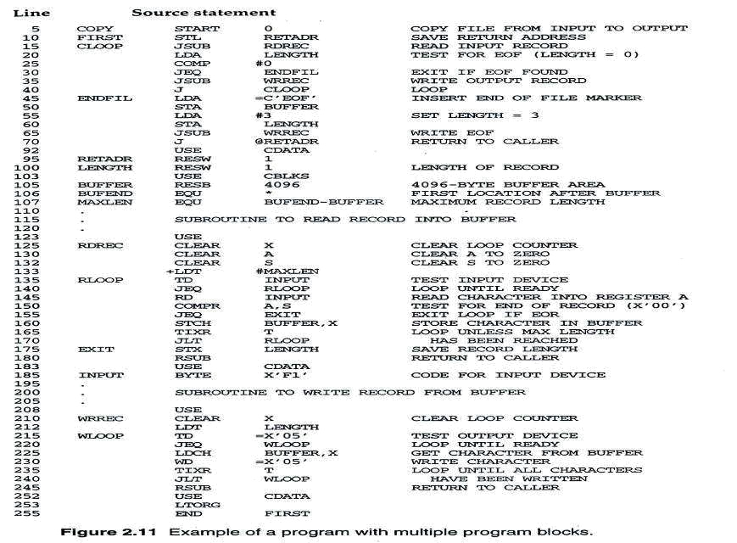

- Each source line is given a relative address assigned and a block number
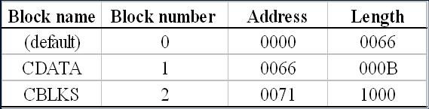
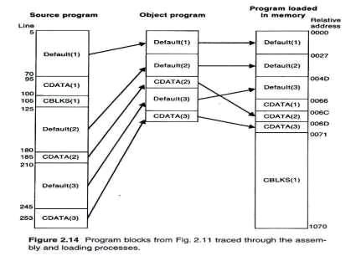

- What is one pass assembler? Explain the functioning of one-pass assembler.
➢ One-pass assemblers are used when
o it is necessary or desirable to avoid a second pass over the source program o the external storage for the intermediate file between two passes is slow or

is inconvenient to use
➢ Main problem: forward references to both data and instructions
➢ One simple way to eliminate this problem: require that all areas be defined before they are referenced.

o It is possible, although inconvenient, to do so for data items. o Forward jump to instruction items cannot be easily eliminated.

Sample Program for a One-Pass Assembler

Sample Program for a One-Pass Assembler
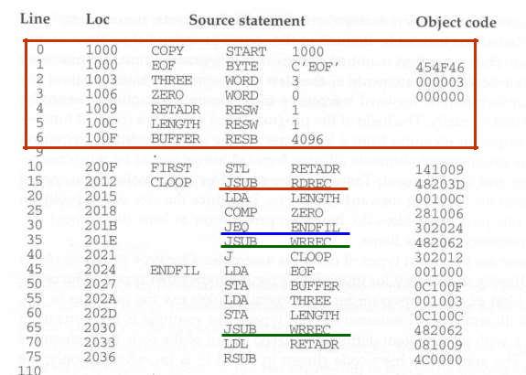
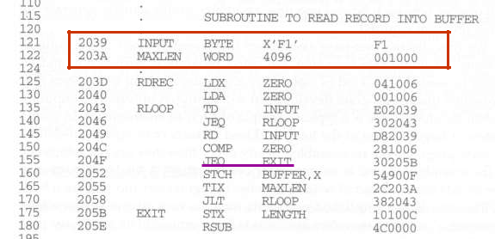
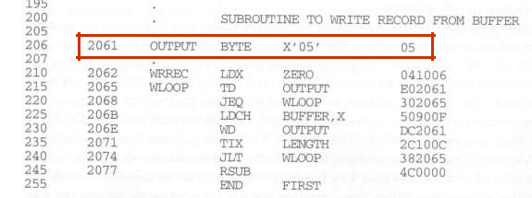

Load-and-Go Assembler

- Load-and-go assembler generates their object code in memory for immediate execution.

- No object program is written out, no loader is needed.

- It is useful in a system oriented toward program development and testing such that the efficiency of the assembly process is an important consideration.

- Load-and-go assembler
  - Omits the operand address if the symbol has not yet been defined

  - Enters this undefined symbol into SYMTAB and indicates that it is undefined

  - Adds the address of this operand address to a list of forward references associated with the SYMTAB entry

  - Scans the reference list and inserts the address when the definition for the symbol is encountered.

  - Reports the error if there are still SYMTAB entries indicated undefined symbols at the end of the program

  - Search SYMTAB for the symbol named in the END statement and jumps to this location to begin execution if there is no error

Object Code in Memory and SYMTAB

After scanning line 40
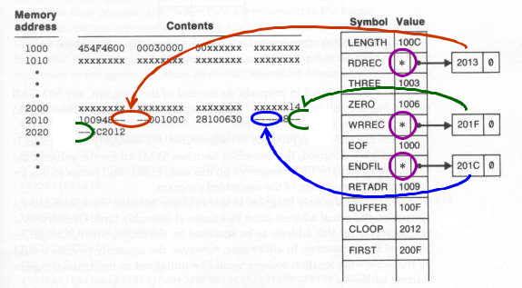

Object Code in Memory and SYMTAB

After scanning line 160
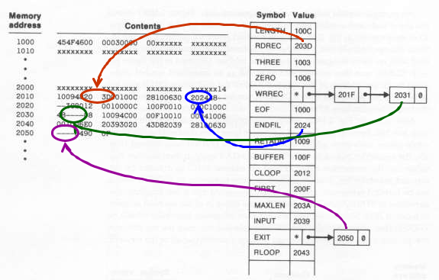

Object Program from One-Pass Assembler
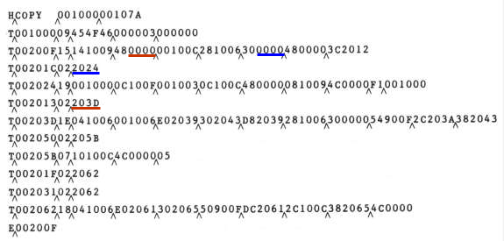

21) What is a multi-pass assembler? Explain with an example,the functioning of
  - multi-pass assembler.
Multi-Pass Assemblers

- Prohibiting forward references in symbol definition:
– This restriction is not a serious inconvenience.

– Forward references tend to create difficulty for a person reading the program.

- Allowing forward references
– To provide more flexibility
– Solution:

      - A multi-pass assembler that can make as many passes as are needed to process the definitions of symbols.

      - Only the portions of the program that involve forward references in symbol definition are saved for multi-pass reading.

- For a two pass assembler, forward references in symbol definition are not allowed:

ALPHA EQUBETA

BETA EQU DELTA DELTA RESW 1

- Reason: symbol definition must be completed in pass 1.
- Motivation for using a multi-pass assembler
– DELTA can be defined in pass 1
– BETA can be defined in pass 2
– ALPHA can be defined in pass 3
Implementation
- A symbol table is used
– to store symbol definitions that involve forward references
– to indicate which symbols are dependant on the values of others
– to facilitate symbol evaluation
- For a forward reference in symbol definition, we store in the SYMTAB:
– the symbol name
– the defining expression
– the number of undefined symbols in the defining expression

– the undefined symbol (marked with a flag *) associated with a list of symbols depend on this undefined symbol.

- When a symbol is defined, we can recursively evaluate the symbol expressions depending on the newly defined symbol.

Forward Reference Example
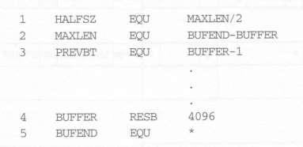
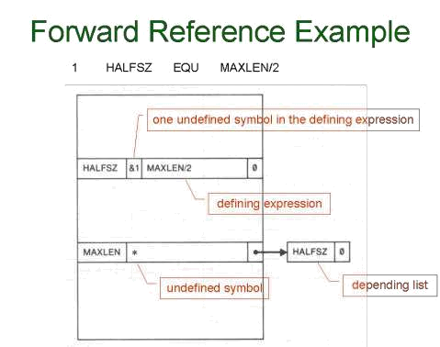

2 MAXLEN EQU BUFEND-BUFFER
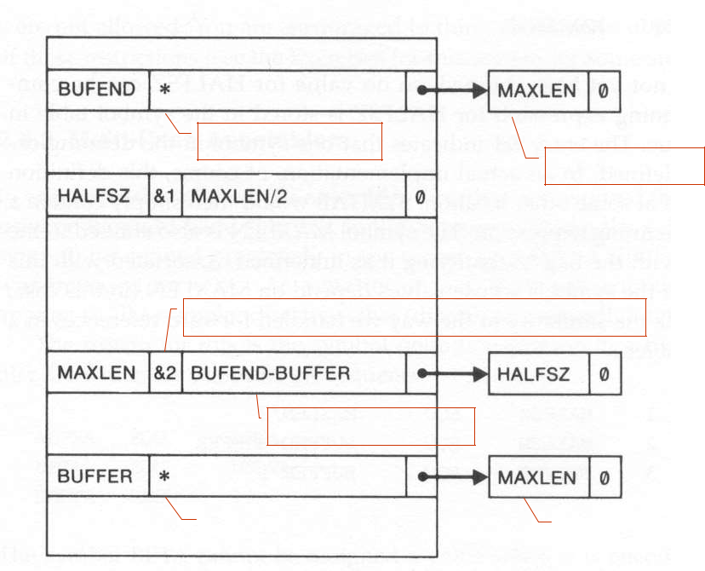

undefined symbol

depending list

two undefined symbol in the defining expression

defining expression

undefined symbol
undefined symbol |  | depending list

3 PREVBT EQU BUFFER-1
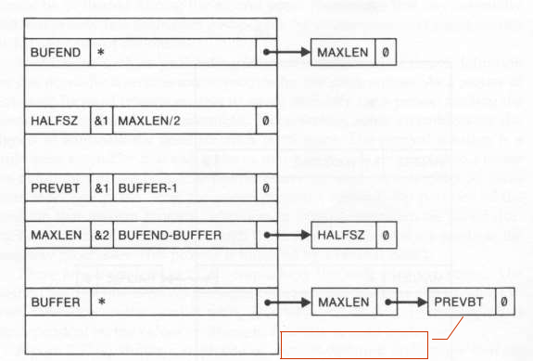

appended to the list

4 BUFFER RESB 4096
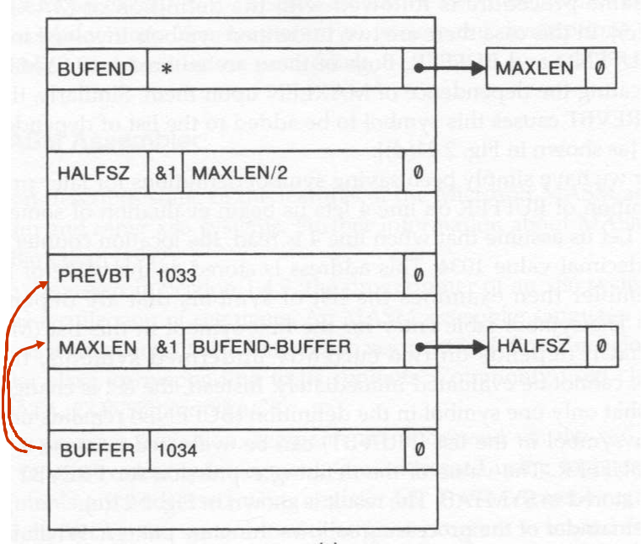

5 BUFEND EQU *
