SYSTEM SOFTWARE
QUESTION BANK- LOADERS AND LINKERS

Definitions
Loading
– Copies a object program into memory for execution.

Relocation

– Modifies an program so it can be loaded at a location different from the one specified at assembly or compilation.

Linking

– Combines two or more object files and the references between them.

Loader

– System program that performs the loading function. Linker or Linkage Editor

– Performs the linking function.
– Compilers & assemblers for a given machine produce files in the same format.

1) Define Loading,Relocation and Linking.
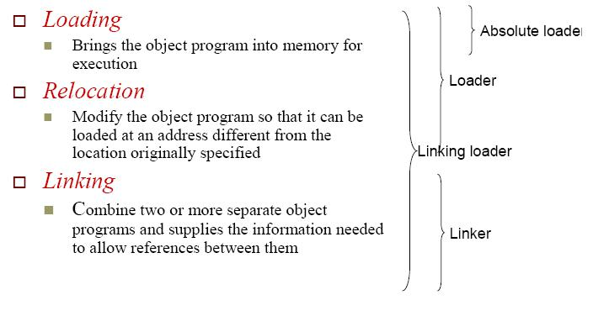

- What is the basic function of a loader? The most fundamental functions of a loader:
Bringing an object program into memory and starting its execution

- What are the characteristics of an absolute loader?

  - No linking and relocation needed

  - Records in object program perform

- Header record

- Check the Header record for program name, starting address, and length (available memory)

- Text record

- Bring the object program contained in the Text record to the indicated address

- End record
  - Transfer control to the address specified in the End record

- Write an algorithm for an absolute loader. Algorithm for an absolute loader
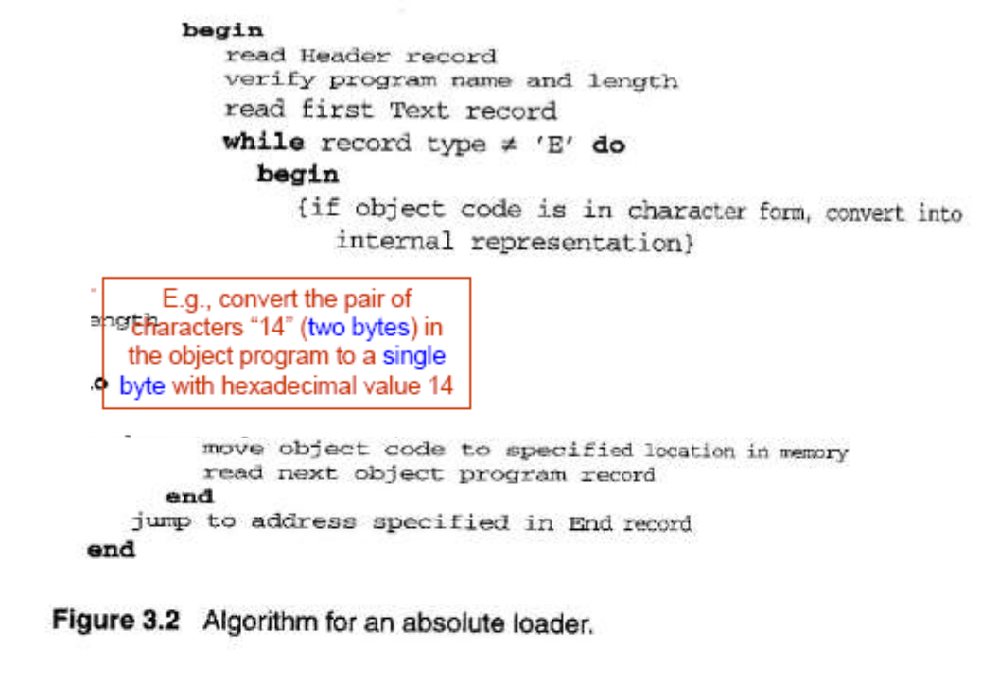

5) What is a bootstrap loader?

When a computer is first tuned on or restarted, a special type of absolute loader, the bootstrap loader loads the first program (usually O.S.) to be run into memory

- Explain SIC bootstrap loader.
  - The bootstrap itself begins at address 0

  - It loads the OS starting address 0x80

  - No header record or control information, the object code is consecutive bytes of memory

  - After load the OS, the control is transferred to the instruction at address 80.
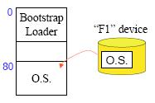

Bo o t s t r a p l o a d e r f o r S I C / X E

begin
X=0x80 ; the address of the next memory location to be loaded

Loop
A¬GETC ; read one char. From device F1 and convert it from the

  - ASCII character code to the value of the hex digit save the value in the high-order 4 bits of S A¬GETC

A¬ (A+S) ; combine the value to form one byte

store the value (in A) to the address represented in register X X¬X+1

End

- What are the disadvantages of absolute loaders? Drawback of absolute loaders

o Programmer needs to specify the actual address at which it will be loaded into memory.

o Difficult to run several programs concurrently, sharing memory between them.

o Difficult to use subroutine libraries.

o Solution: a more complex loader that provides Program relocation

Program linking

- What are relocatable loaders? What are different types of relocatable loaders?

Loaders that allow for program relocation are called relocating loaders or relative loaders.

o Two methods for specifying relocation as part of the object program

Modification records

o Suitable for a small number of relocations required when relative or immediate addressing modes are extensively used

Relocation bits

o Suitable for a large number of relocations required when only direct addressing mode can be used in a machine with fixed instruction format (e.g., the standard SIC machine)

- Explain with an example ,the relocatable loader.
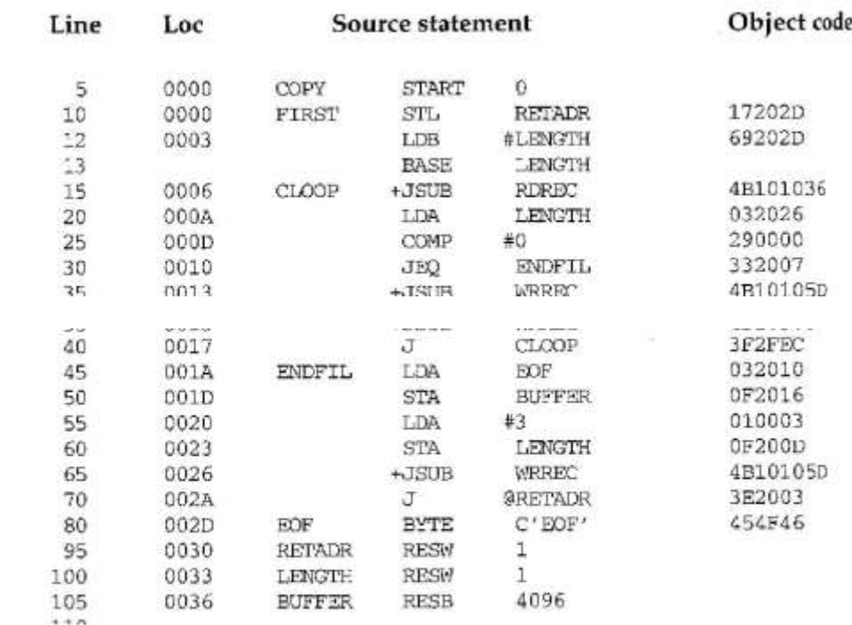
Example of a SIC/XE Program
Relocatable Program
o Modification record
Col 1 M

Col 2-7 Starting location of the address field to be modified, relative to the beginning of the program (hex)

Col 8-9 length of the address field to be modified, in half-bytes E.g M^000007^05

Pass the address – modification information to the relocatable loader Beginning address of the program is to be added to a field that begins at addr ox000007 and is 5 bytes in length.
Object Program with Relocation by Modification Records
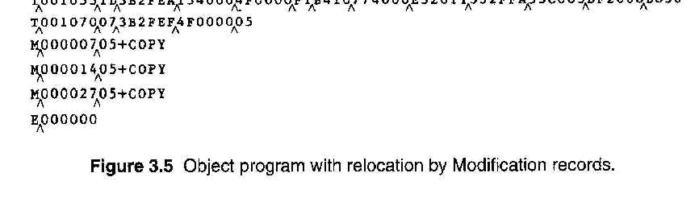

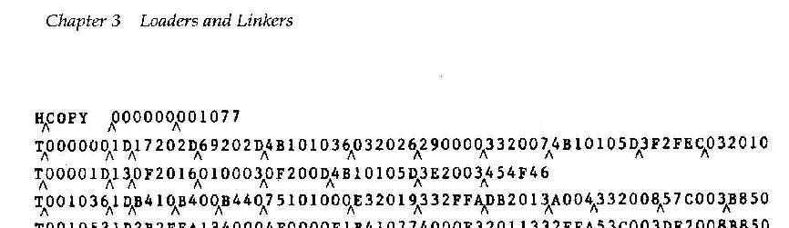

10) What is linking?

Linking, which combines two or more separate object programs and supplies the information needed to allow references between them .

11) What are loader design options?
Loader Design Options
Linking loaders

Perform all linking and relocation at load time

Linking editors
Perform linking before the program is loaded for execution.
Dynamic linking
Perform linking at execution time

- What is dynamic linking? Explain with an example.

Dynamic Linking refers to postponing the linking function until execution time.

A subroutine is loaded and linked to the rest of the program when it is first called (Dynamic linking, dynamic loading, or load on call)

Allow several executing programs to share one copy of a subroutine or library

In object-oriented system, it allows the implementation of the object and its methods to be determined at the time the program is run

Dynamic linking provides the ability to load the routines only when they are needed
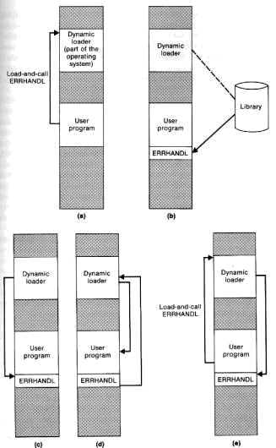

Dynamically loaded must be called via an operating system service request
Load-and-call service

- OS examines its internal tables to determine whether or not the routine is already loaded
- Routine is loaded from library

    - Control is passed from OS to the called subroutine o Subroutine is finished

o Calling to a subroutine which is already in memory
Dynamic Linking : Binding of the name to an actual address is delayed from load time until execution time

- What are the advantages of dynamic linking?
Dynamic Linking

Advantages
Load the routines when they are needed, the time

and memory space will be saved.

Avoid the necessity of loading the entire library for each execution o i.e. load the routines only when they are needed

Allow several executing programs to share one copy of a subroutine or library (Dynamic Link Library, DLL)

- What is the difference between linking loader and linkage editors?
A linking loader performs
  - All linking and relocation operations
  - Automatic library search
  - Loads the linked program directly into memory for execution
A linkage editor

Produces a linked version of program (often called a load module or an executable image), which is written to a file or library for later execution

- A simple relocating loader can be used to load the linked version of program into memory

▪ The loading can be accomplished in one pass with no external symbol table required
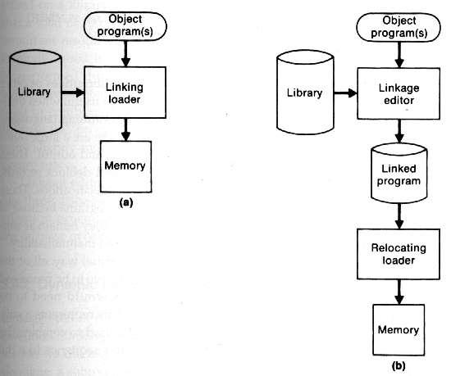

- A linkage editor

- Resolution of external references and library searching are only performed once
- In the linked version of programs
  - All external references are resolved, and relocation is

indicated by some mechanism such as modification records or a bit mask
- External references is often retained in the linked program

  - To allow subsequent relinking of the program to replace control sections, modify external references, etc.

Linking Loader vs. Linkage Editor
- Linking loader

- Searches libraries and resolves external references every time the program is executed.
- Avoid the writing and reading the linked program.
➢ Linkage editor
o Resolution of external reference and library searching are only performed once
Linking loader
- Suitable when a program is reassembled for nearly every execution

- In a program development and testing environment

- When a program is used so infrequently that it is not

- worthwhile to store the assembled and linked version.

Linkage editor

  - If a program is to be executed many times without being reassembled, the use of a linkage editor substantially reduces the overhead required.

- What are machine independent loader features?
Machine-Independent Loader Features

- loading and linking are often thought of as operating system service functions.

- Machine independent loader features: o Automatic Library Search

o Loader Options

Automatic Library Search for handling external references

- Allows programmers to use standard subroutines without explicitly including them in the program to be loaded.

- The routines are automatically retrieved from a library as they are needed during linking.

Linking loaders that support automatic library search:
- Enter the symbols from each Refer record into ESTAB

- When the definition is encountered (Define record), the address is assigned

- At the end of Pass 1, the symbols in ESTAB that remain undefined represent unresolved external references

- The loader searches the libraries specified for routines that contain the definitions of these symbols, and processes the subroutines found by this search exactly as if they had been part of the primary input stream

- Since the subroutines fetched from a library may themselves contain external references ,the library search process may be repeated.

- The programmers can override the standard subroutines in the library by supplying their own routines

- What are machine independent loader features?
Common Loader Options – Command Language
Specifying alternative sources of input :

INCLUDE program-name(library-name)

  - Direct the loader to read the designed object program name specified as a part of input program.

Changing or deleting external references

DELETE csect-name
  - Delete the named control section(s) from the program loaded
when not used
CHANGE name1, name2

  - Change the external symbol name 1 to name 2 appeared in the
object program

Example
INCLUDE READ(UTLIB)

INCLUDE WRITE(UTILB)
DELETE RDREC, WRREC
CHANGE RDREC, READ
CHANGE WRREC, WRITE

- Write short notes on MSDOS - Linker
MS-DOS Linker
- MS-DOS assembler (MASM) produce object modules (.OBJ)

- MS-DOS LINK is a linkage editor that combines one or more modules to produce a complete executable program (.EXE)

- MS-DOS object module

o THEADER similar to Header record in SIC/XE MODEND similar to End record in SIC/XE

MS-DOS Object Module
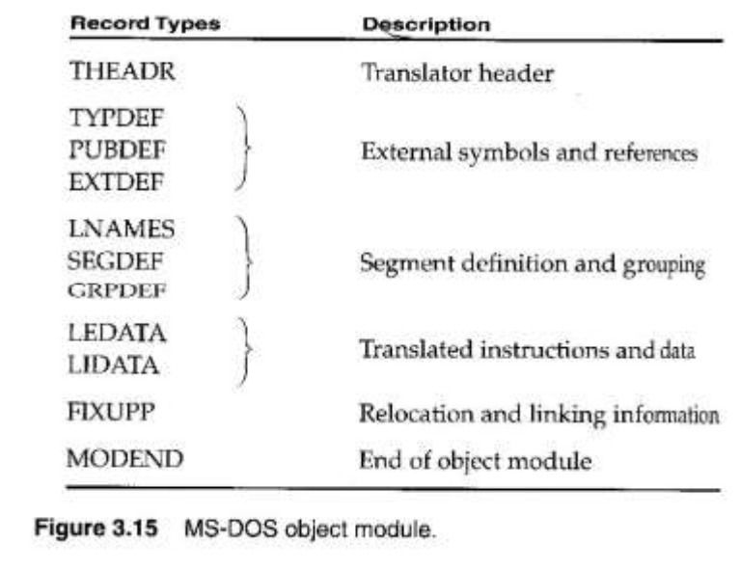

- Give an example of program using libraries.

Example of Programs Using Libraries

main.c
include <stdio.h>
extern int a();
extern int b();
main()
{
int ret1, ret2;
ret1=a();
ret2=b();
printf("\n ret from a()= %d", ret1);

printf("\n ret from b()= %d", ret2);
}

a.c
int a()
{
return 5;
}i
nt a1()
{
return 8;
}

b.c
int b()
{
return 5;
}

