 | SYSTEM SOFTWARE
QUESTION BANK- |  |  | MACRO PROCESSORS

1) Define Macro.
- A macro instruction (macro) is a notational convenience for the programmer.

- It allows the programmer to write a shorthand version of a program

- A macro represents a commonly used group of statements in the source programming language.

  - Expanding the macros - the macro processor replaces each macro instruction with the corresponding group of source language statements.

- What is a macro processor?
A macro processor - Essentially involve the substitution of one group

of characters or lines for another. Normally, it performs no analysis of the text it handles. It doesn’t concern the meaning of the involved statements during macro expansion

o The design of a macro processor generally is machine independent.
Three examples of actual macro processors:

- A macro processor designed for use by assembler language programmers o Used with a high-level programming language

o General-purpose macro processor, which is not tied to any particular language
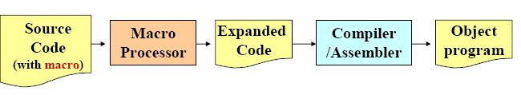

- What are the basic macro processor functions? Basic Macro Processors Functions

Macro processor should processes the

Macro definitions
o Define macro name, group of instructions

Macro invocation (macro calls)

o A body is simply copied or substituted at the point of call Expansion with substitution of parameters

o Arguments are textually substituted for the parameters
o The resulting procedure body is textually substituted for the call

- What are the Assembler directives used for Macro Definition? Macro Definition

Two new assembler directives are used in macro definition: MACRO: identify the beginning of a macro definition MEND: identify the end of a macro definition

o label op operands

name MACRO parameters
:

body
:

MEND

o Parameters: the entries in the operand field identify the parameters of the macro instruction

We require each parameter begins with ‘&’

o Body: the statements that will be generated as the expansion of the macro. o Prototype for the macro:

The macro name and parameters define a pattern or prototype for the macro instructions used by the programmer

- Give an example program which uses Macro Definition.
Macro Definition
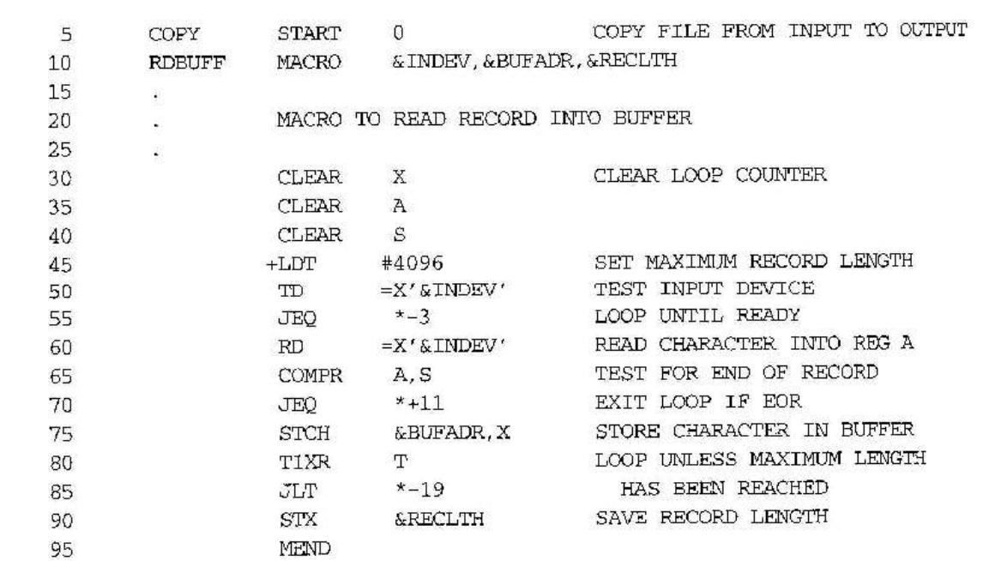
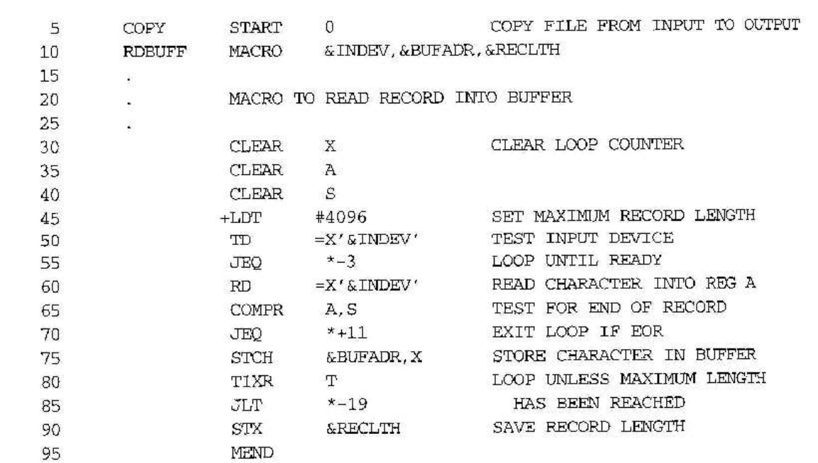

6) How Macro is invoked in a program? Give example.

Macro Invocation
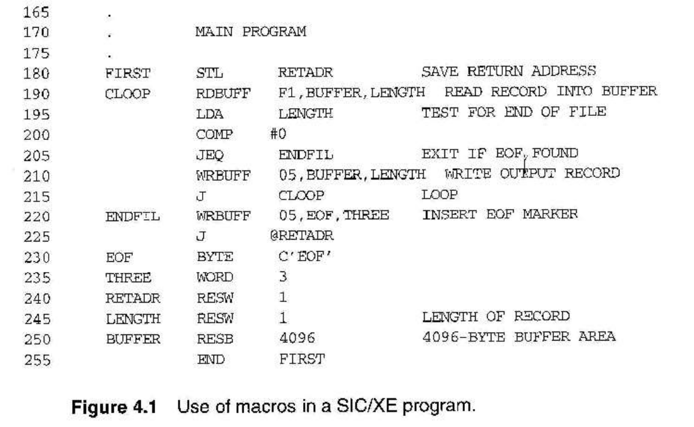

7) What is Macro Expansion? Give an example.

Macro Expansion

Each macro invocation statement will be expanded into the statements that form the body of the macro.

o Arguments from the macro invocation are substituted for the parameters in the macro prototype.

The arguments and parameters are associated with one another according to their positions.

o The first argument in the macro invocation corresponds to the first parameter in the macro prototype, etc.

Macro Expansion Example
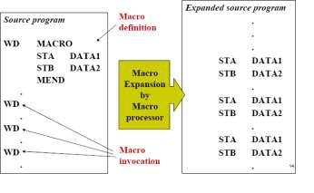

Program From Fig. 4.1 with Macros Expanded (fig. 4.2)(Cont.)
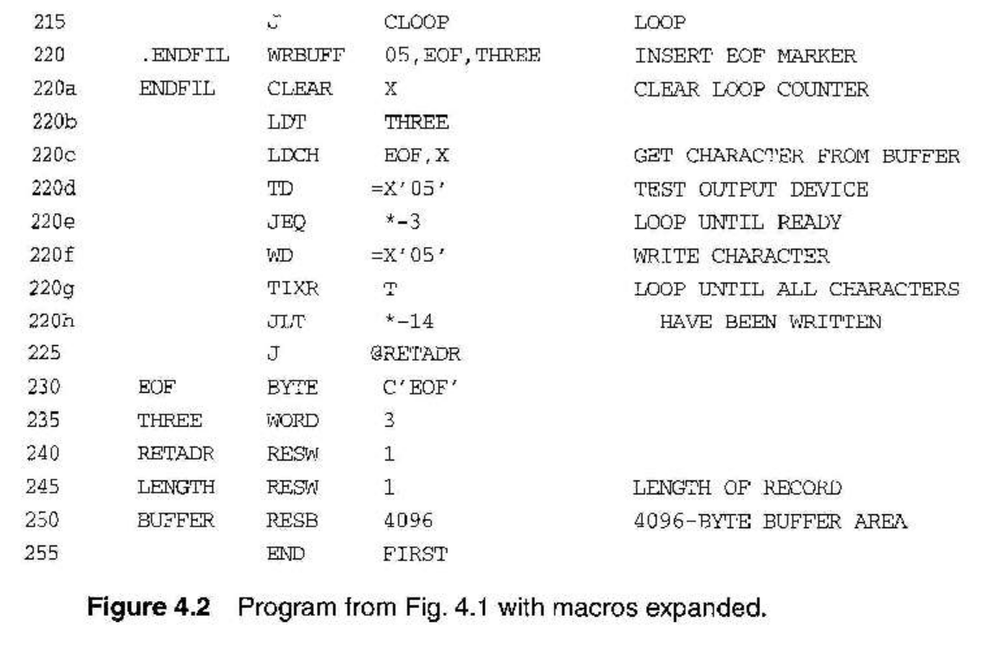

8)Explain the functions of two pass macro processor.

Two-pass macro processor
- Two-pass macro processor
- Pass1: process all macro definitions

  - Pass2: expand all macro invocation statements o Problem

▪ Does not allow nested macro definitions o Nested macro definitions

o The body of a macro contains definitions of other macros
▪ Because all macros would have to be defined during the

▪ first pass before any macro invocations were expanded o Solution

    - One-pass macro processor

- What is the characteristic of one pass macro processor?

One-pass macro processor
Every macro must be defined before it is called

One-pass processor can alternate between macrodefinition and macro expansion
Nested macro definitions are allowed

- What are the data structures used by the macro processor?
➢ Data Structures

o MACRO DEFINITION TABLE (DEFTAB)
  - Macro prototype

  - States that make up the macro body

  - Reference to parameters are converted to a positional notation. o MACRO NAME TABLE (NAMTAB)

  - Role: an index to DEFTAB

  - Pointers to the beginning and end of the definition in DEFTAB o MACRO ARGUMENT TABLE (ARGTAB)

  - Used during the expansion

  - Invocation ➔ Arguments are stored in ARGTAB according to their position
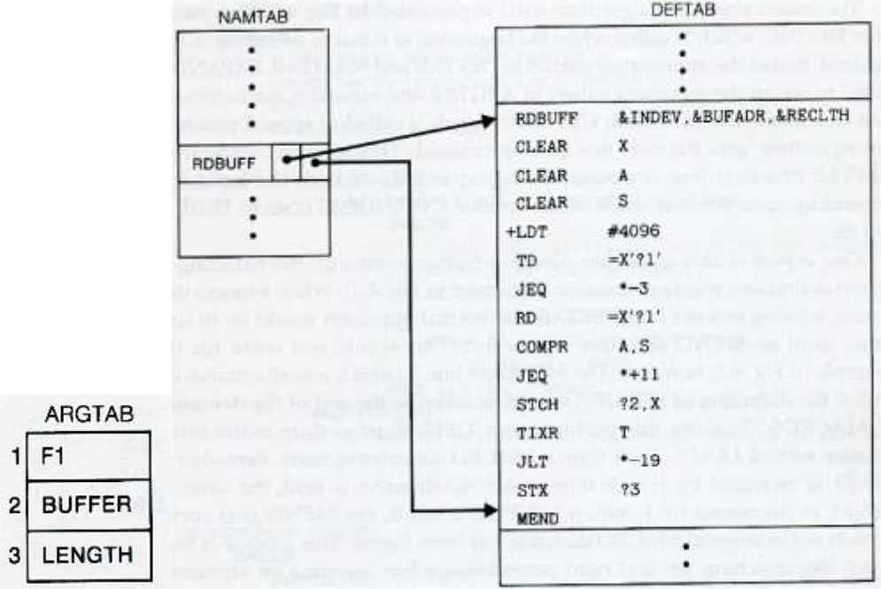

- Write an algorithm for the Macro processor and explain. Algorithm and Data Structure (4)
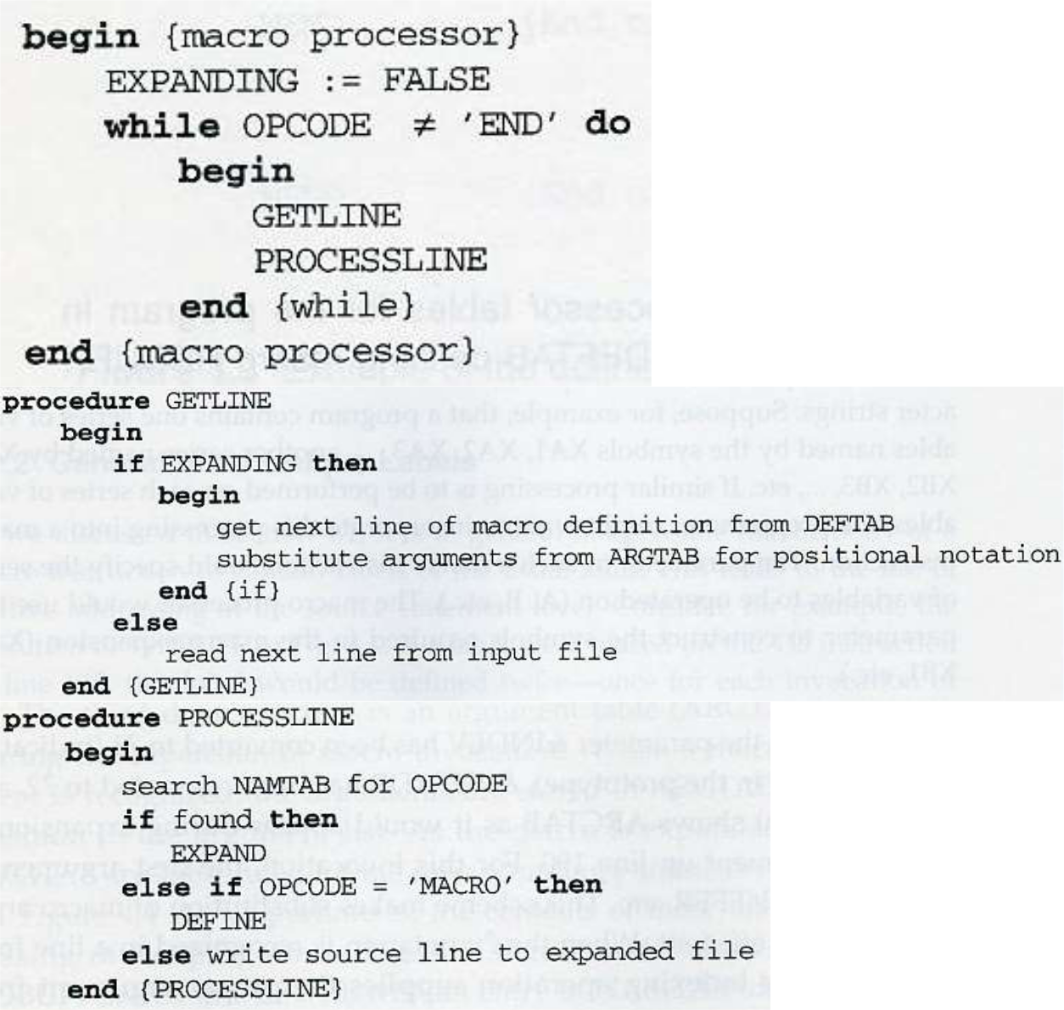
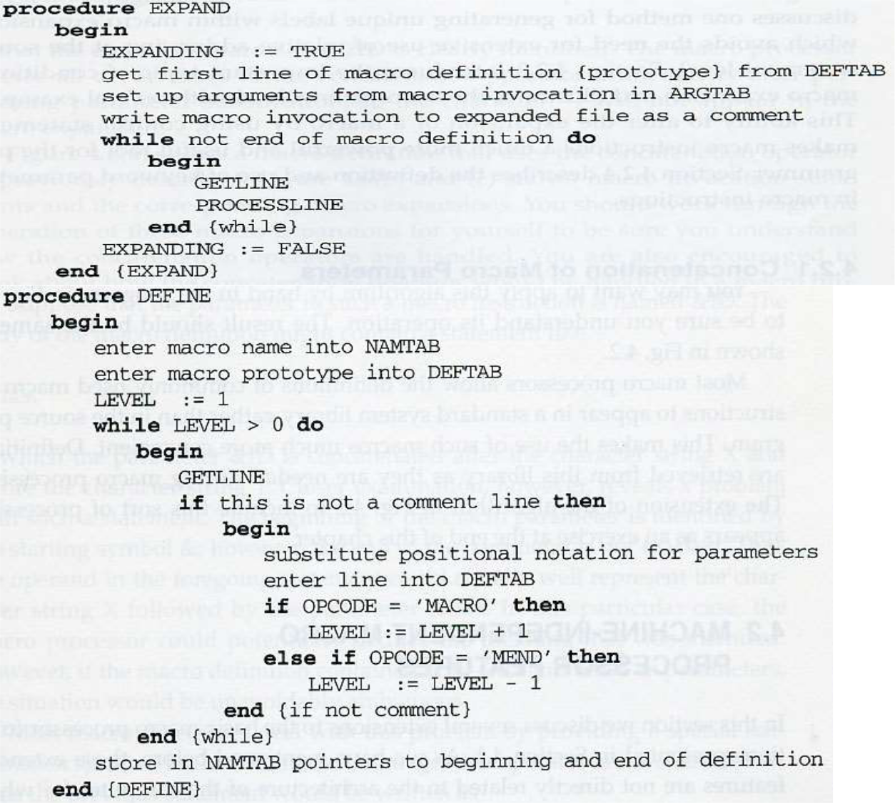

- What is the difference between a Macro and a subroutine? Differences between Macro and Subroutine

  - After macro processing, the expanded file can be used as input to the assembler.

  - The statements generated from the macro expansions will be assembled exactly as though they had been written directly by the programmer.
  - The differences between macro invocation and subroutine call

- The statements that form the body of the macro are generated each time a macro is expanded.

- Statements in a subroutine appear only once, regardless of how many times the subroutine is called.

- What are the machine independent features of macro processors? Other Macro Features

➢ Concatenation of macro parameters ➢ Generation of unique labels
➢ Conditional macro expansion ➢ Keyword Macro Parameters

Concatenation of Macro Parameters
➢ Pre-concatenation
o LDA X&ID1 ➢ Post-concatenation

o LDA X&ID1 ➢ Example: Figure 4.6

Concatenation Example
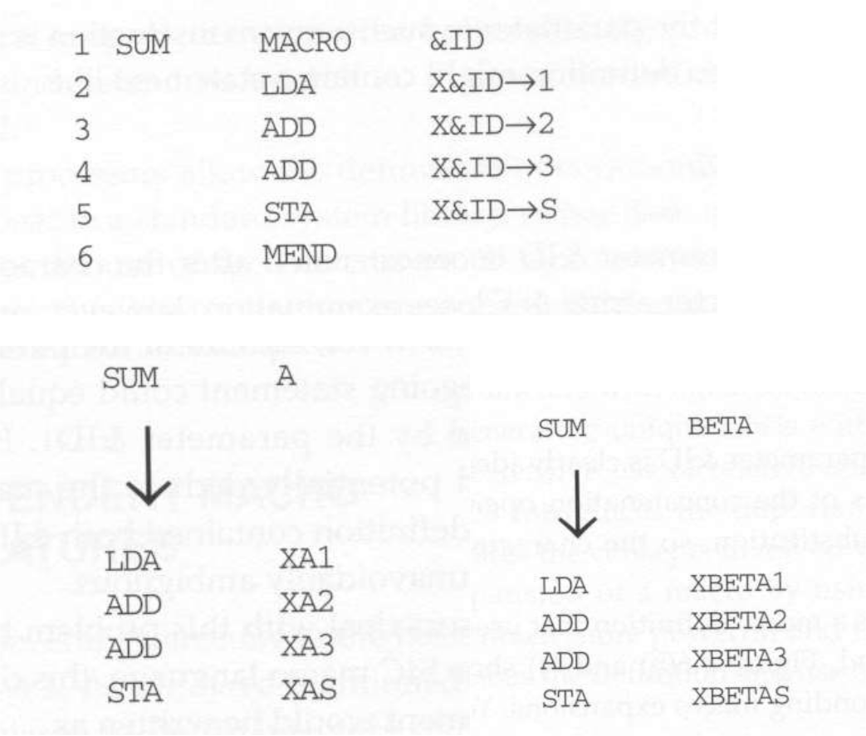

Generation of Unique Labels
- Example
o JEQ *-3
  - inconvenient, error-prone, difficult to read
- Example Figure 4.7
✓ $LOOP TD =X’&INDEV’
- 1st call:
  - $AALOOPTD=X’F1’
- 2nd call:
  - $ABLOOPTD=X’F1’
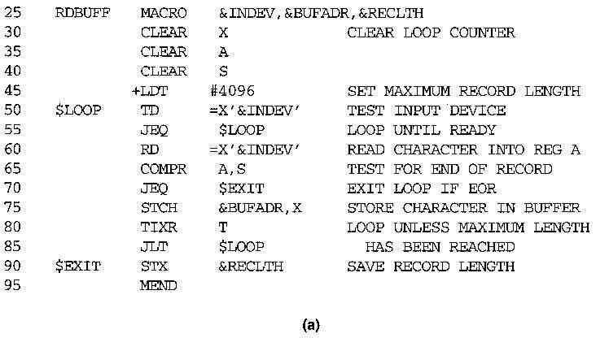

RDBUFF F1, BUFFER, LENGTH
